## **Name: Sai Mutya Naveen Bathula**

**ID: 22024816**

**Applied Data Science**

**Assignment - 1**

**Github-link:** *<https://github.com/Naveenbsm/Applied-Data-Science.git>*

**Link to Dataset:** *<https://drive.google.com/file/d/17E9N7mbBo87BrV_rPNoJZurt5f_614LE/view>*

*(for better access I have downloaded the dataset from the source and added a google drive link)*

**Visualization 1: Line Plot of Urban population (% of total) for 6 countries**

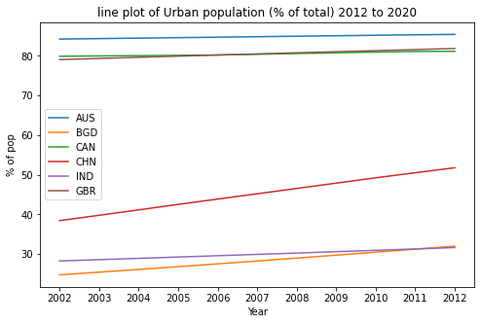

*Fig 1: A Line Plot For Urban Population(% of total)*

A line plot showing the Urban population in % for 6 different countries from the year 2002 to 2012. We can deduce that the population of Australia has been constant and so is the population of Great Britain and Canada. We can see an increasing change in the population of China and Bangladesh over the years.

**Visualization 2: Pie Chart**

Pie charts are most useful for showing data as a percentage of whole. Fig 2.1 shows the data for the total percentage of urban population for the year 2002. Clearly the countries with the lowest percentage of urban population are Bangladesh, Afghanistan, India, and China. And in fig 2.2 we can see an increase in the percentage of China, Japan and Bangladesh.

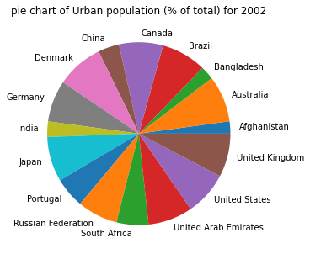

*Fig 2.1: A Pie Chart For Urban Population For The Year 2002*

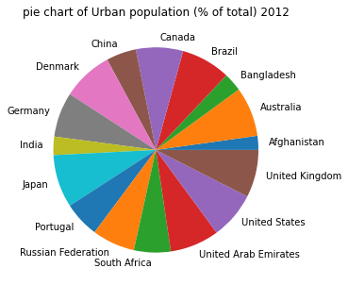

*Fig 2.2: A Pie Chart For Urban Population For The Year 2012*

**Visualization 3: Bar Chart**

In fig 3 the urban population percentage for 16 countries can be seen for the year 2012. From this chart we can observe that Japan has the highest urban population for this year and Afghanistan has the lowest urban population percentage. Australia, Brazil and UAE have similar percentages. And China has 50 % of urban population in the year 2012.

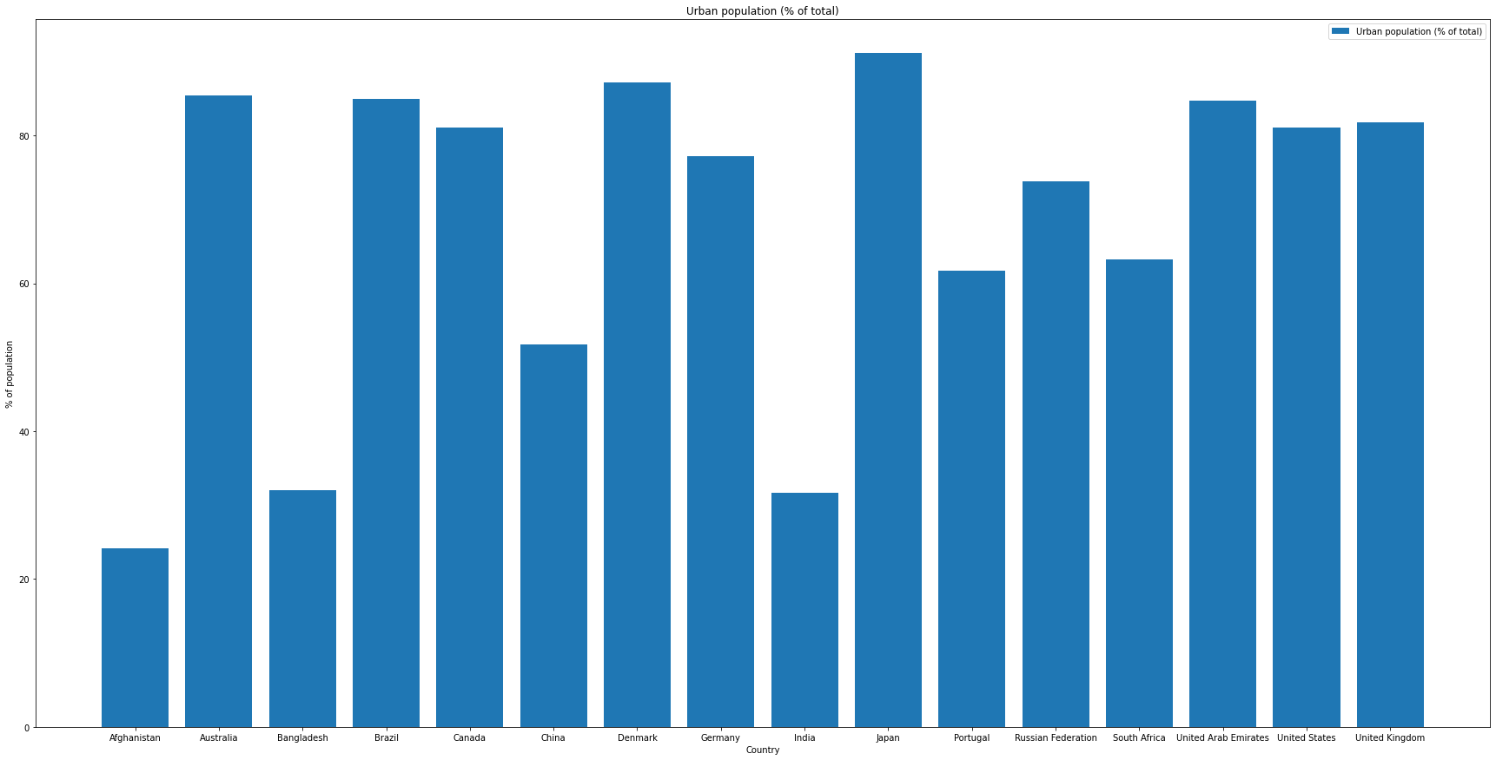

*Fig 3: A Bar Chart For Urban Population For The Year 2012*